Numpy and Pandas Doc
NumPy Basics
import numpy as np

# 1. Array Creation
np.array([1,2,3])
np.array([[1,2,3],[4,5,6]])
np.zeros((2,3))
np.ones((3,3))
np.full((2,2), 7)
np.eye(3)
np.arange(0,10,2)
np.linspace(0,1,5)
np.random.rand(3,3)
np.random.randn(3,3)
np.random.randint(1,100,5)

# 2. Shape, Reshape & Flatten
arr = np.arange(12).reshape(3,4)
arr.shape
arr.size
arr.ndim
arr.flatten()
arr.ravel()

# 3. Indexing & Slicing
arr = np.array([10,20,30,40,50])
arr[0], arr[-1]
arr[1:4]
arr[::2]
arr[1:4] = 99

m = np.array([[1,2,3],[4,5,6],[7,8,9]])
m[0,1]
m[1,:]
m[:,2]

# 4. Stacking Arrays
a = np.array([1,2,3])
b = np.array([4,5,6])
np.vstack((a,b))
np.hstack((a,b))
np.concatenate([a,b])

# 5. Set Operations
a = np.array([1,2,3,4,5])
b = np.array([4,5,6,7])
np.union1d(a,b)
np.intersect1d(a,b)
np.setdiff1d(a,b)

# 6. Arithmetic & Statistics
a = np.array([10,20,30])
a+1; a-1; a*2; a/2
np.mean(a)
np.median(a)
np.std(a)
np.var(a)
np.min(a)
np.max(a)
np.sum(a)
np.prod(a)
np.cumsum(a)
np.cumprod(a)

# 7. Boolean Indexing & Masking
arr = np.array([10,20,30,40,50])
arr[arr > 25]
arr[(arr>10) & (arr<40)]

# 8. Broadcasting
arr = np.array([1,2,3])
arr + 5
arr * np.array([10,20,30])

# 9. Matrix Operations
n1 = np.array([[1,2,3],[4,5,6],[7,8,9]])
n2 = np.array([[9,8,7],[6,5,4],[3,2,1]])
np.add(n1,n2)
np.subtract(n1,n2)
np.multiply(n1,n2)
n1.dot(n2)
np.transpose(n1)
np.linalg.inv([[1,2],[3,4]])
np.linalg.det([[1,2],[3,4]])
np.linalg.eig([[1,2],[2,3]])

# 10. Save & Load Arrays
arr = np.array([1,2,3,4,5])
np.save("array.npy", arr)
np.load("array.npy")
np.savetxt("array.txt", arr)
np.loadtxt("array.txt")

Pandas Basics
import pandas as pd

# 1. Series
s = pd.Series([1,2,3,4], index=['a','b','c','d'])
s['a']
s.values
s.index

# 2. DataFrame Creation
data = {'Name':['A','B','C'], 'Age':[20,25,30]}
df = pd.DataFrame(data)
pd.DataFrame(np.random.rand(3,3), columns=['A','B','C'])

# 3. Selecting Rows & Columns
df['Name']
df[['Name','Age']]
df.loc[0]
df.iloc[1:3]
df.at[0,'Name']

# 4. Filtering
df[df['Age'] > 22]
df.query("Age > 22 & Name == 'B'")

# 5. Handling Missing Data
df = pd.DataFrame({'A':[1,2,np.nan], 'B':[4,np.nan,6]})
df.fillna(0)
df.dropna()
df.isnull().sum()

# 6. Sorting
df.sort_values(by='Age', ascending=False)
df.sort_index()

# 7. GroupBy & Aggregation
df.groupby('Age').size()
df.groupby('Age')['Name'].count()
df.groupby('Age').agg({'Name':'count'})

# 8. Merging & Concatenation
df1 = pd.DataFrame({'ID':[1,2], 'Name':['A','B']})
df2 = pd.DataFrame({'ID':[1,2], 'Salary':[1000,2000]})
pd.merge(df1, df2, on='ID')
pd.concat([df1,df2], axis=0)
pd.concat([df1,df2], axis=1)

# 9. Exporting Data
df.to_csv("output.csv", index=False)
pd.read_csv("output.csv")

# 10. Working with Iris Dataset
import seaborn as sns
iris = sns.load_dataset("iris")
iris.head()
iris.info()
iris.describe()
iris['species'].value_counts()

# 11. Visualization
import matplotlib.pyplot as plt
iris['sepal_length'].hist(); plt.show()
plt.scatter(iris['sepal_length'], iris['petal_length'])
plt.xlabel("Sepal Length"); plt.ylabel("Petal Length"); plt.show()
sns.pairplot(iris, hue='species')
sns.heatmap(iris.corr(), annot=True)

# 12. Index Operations
df = pd.DataFrame({'Name':['A','B','C'], 'Age':[20,25,30]})
df.set_index('Name', inplace=True)
df.reset_index(inplace=True)

# 13. Advanced Joins
df1 = pd.DataFrame({'ID':[1,2,3], 'Name':['A','B','C']})
df2 = pd.DataFrame({'ID':[2,3,4], 'Salary':[2000,3000,4000]})
pd.merge(df1, df2, on='ID', how='inner')
pd.merge(df1, df2, on='ID', how='left')
pd.merge(df1, df2, on='ID', how='right')
pd.merge(df1, df2, on='ID', how='outer')

# 14. Pivot Tables
df = pd.DataFrame({
'Department':['HR','HR','IT','IT','Finance','Finance'],
'Employee':['A','B','C','D','E','F'],
'Salary':[3000,4000,5000,6000,7000,8000]
})
pd.pivot_table(df, values='Salary', index='Department', aggfunc='mean')
MatplotLib
- Matplotlib is a Python library used for creating graphs, plots, and charts.
- It helps to visualize data in different forms like line charts, bar graphs, pie charts, scatter plots, etc.

import numpy as np
import matplotlib.pyplot as plt
x = np.arange(1,11)
y = 2 * x
plt.plot(x,y,color = 'g')
plt.title("Line plot")
plt.xlabel("x-label")
plt.ylabel("y-label")
plt.show()
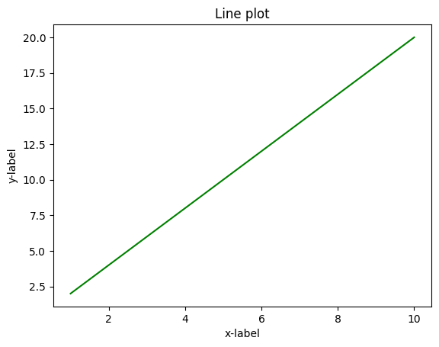
import numpy as np
#Adding two lines in the same plot
x = np.arange(1,11)
y2 = 3 * x
y1= 2 * x
plt.plot(x,y1,color = 'g')
plt.plot(x,y2,color = 'r')
plt.title("Line plot")
plt.xlabel("x-label")
plt.ylabel("y-label")
plt.show()
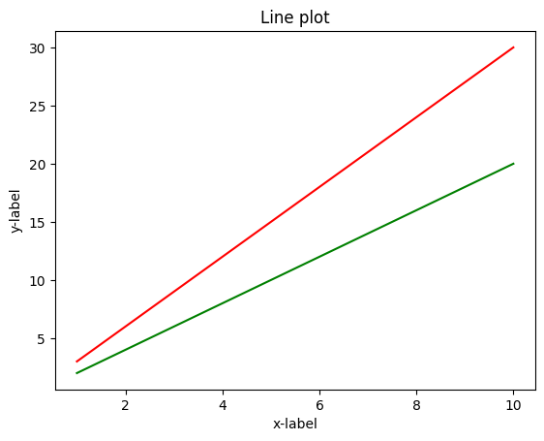
#Adding the subplot
plt.subplot(1,2,1)
plt.plot(x,y1, color='violet', linestyle = ':', linewidth = 2)
plt.title('Lineplot')
plt.xlabel('x-axis')
plt.ylabel('y-axis')
